Runs batted in
According to rule 9.04 of the OBR, a run should be considered as having been batted in (RBI) if the runner who scored was driven to home base by the batter (or scored because of the batter). It follows that a run counts as having been batted in if the runner reached home base because of:
- a safe hit;
- a batted ball that caused the batter or another runner to be put out, but which enabled the runner on third base to score;
- a sacrifice bunt or sacrifice fly;
- a base on balls, or the award of first base for being touched by a pitched ball, or for interference or obstruction (with bases full), which forces the runner on third base over the plate;
- an error being made on a play on which a runner from third base would ordinarily score, before two are out.
ATTENTION: If there are two out, a run scored on a batted ball that led to an error, or following an obstruction with bases full, can never count as a run batted in, since if the error had not been committed the inning would have been over and the run would not have been scored.
A run batted in is recorded in the home base square with the batting order number of the batter who enabled the runner to score. This batter is credited with a run batted in, in the appropriate square.
Example 123: With runners on first and third bases, the batter hits a double to the right field, enabling both runners to score.
This means that the fourth batter in the batting order is credited with two runs batted in.
WBSC |  | Traduction dans l’outil de scorage |  | Outil
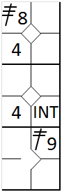 |  | /* Le premier coureur frappe un triple dans le champ centre */  action { batter -> 3B8 }  /* Le coureur suivant gagne la première base sur une interférence du receveur */  action { batter -> INT }  /* Le batteur suivant frappe un double dans le champ droit, les deux coureur marque un point */  action { batter -> 2B9 , runner1 -> +++ , runner3 -> + } |  | 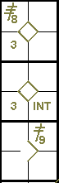

Example 124: With runners on first and third bases, the batter hits a single to the center fielder, who lets the ball run between his legs. Consequently, both runners score and the batter reaches second base.
The run scored by the runner from third base is batted in, as it was scored on the hit.
The run scored by the runner from first base, however, is not a run batted in as it occurred because of the error by the center fielder.
In the example it is judged that the runner from first base would have reached third on the hit alone.
WBSC |  | Traduction dans l’outil de scorage |  | Outil
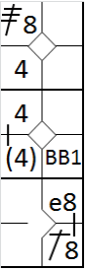 |  | /* Le premier coureur frappe un triple dans le champ centre */  action { batter -> 3B8 }  /* Le coureur suivant gagne la première base sur un 'base on ball' */  action { batter -> BB }  /* Le batteur suivant frappe un simple dans le champ centre et profite d'une erreur pour gagner le deuxième base. Les deux coureur avance, le second profite de l'erreur pour marque le point */  action { batter -> 1B8 e8 , runner1 -> ++ (3) , runner3 -> + } |  | 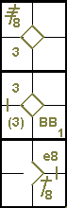
The parentheses around the number four recording the run scored by the second runner indicate that this is not a run batted in, as it was achieved because of an error committed during the fourth batter’s time at bat, and not because of his hit.
Example 125: With runners on first and third bases, the batter hits to the shortstop, who puts out the runner from first base with an assist to the second baseman.
The runner from third scores.
This run counts as a run batted in, since it was scored on the batted ball.
WBSC |  | Traduction dans l’outil de scorage |  | Outil
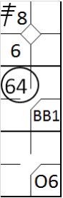 |  | /* Le premier coureur frappe un triple dans le champ centre */  action { batter -> 3B8 }  /* Le coureur suivant gagne la première base sur un 'base on ball' */  action { batter -> BB }  /* Le batteur frappe une balle vers l'arrêt court qui récupère et relai la bale pour retirer le coureur arrivant de la une */  action { batter -> O6 , runner1 -> 64 , runner3 -> + } |  | 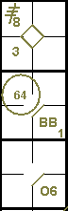

Example 126: With bases full the batter is touched by the ball and goes directly to first base, forcing the other runners to advance.
The runner on third consequently scores.
This run is counted as a run batted in, since it was forced by the batter. The same situation occurs not only when a batter-runner reaches first base on a hit by pitch, but also a base on balls or interference.
WBSC |  | Traduction dans l’outil de scorage |  | Outil
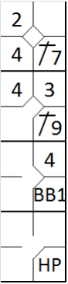 |  | /* Le premier batteur frappe un hit en champ gauche */  action { batter -> 1B7 }  /* Le batteur suivant frappe un hit dans le champ droit, le coureur gagne deux bases */  action { batter -> 1B9 , runner1 -> ++ }  /* Le batteur suivant gagne la première base sur un 'base on ball' */  action { batter -> BB, runner1 -> + }  /* Le batteur suivant gagne la première base sur un 'hit by pitch', tous les coureurs avances */  action { batter -> HP, runner1 -> + , runner2 -> + , runner3 -> + } |  | 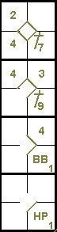

Example 127: With first and second bases occupied, the batter hits a home run, and three runs are scored.
All three runs are batted in, and are credited to the batter (including his own home run).
WBSC |  | Traduction dans l’outil de scorage |  | Outil
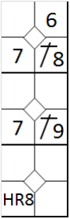 |  | /* Le premier batteur frappe un simple dans le champ centre */  action { batter -> 1B8 }  /* Le batteur suivant frappe un simple dans le champ droit, le coureur avance d'une base */  action { batter -> 1B9 , runner1 -> + }  /* Le batteur frappe un homerun dans le champ centre, tous le monde marque */  action { batter -> HR8 , runner1 -> +++ , runner2 -> ++ } |  | 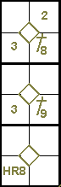

Example 128: With third base occupied, the batter hits a fly ball to the center fielder and is caught out. The runner on third base leaves after the catch and scores.
The run is batted in and is credited to the batter who hit the sacrifice fly.
WBSC |  | Traduction dans l’outil de scorage |  | Outil
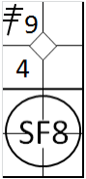 |  | /* Le premier batteur frappe un triple dans le champ droit */  action { batter -> 3B9 }  /* Le batteur frappe un sacrifice fly dans le champ centre, le coureur marque */  action { batter -> SF8 , runner3 -> + } |  | 
NO RUN BATTED IN is scored because of:
- A fielding error;
- A wild pitch, passed ball or balk;
- A play where the batter grounds into a force double play or a reverseforce double play [OBR 9.04(b)(1)];
- A stolen base;
- Fielder’s choice (O/).
Here are some examples.
Example 129: With a runner on third base, the pitcher delivers a wild pitch, allowing the runner to score.
This run is not batted in. The same applies for a passed ball.
WBSC |  | Traduction dans l’outil de scorage |  | Outil
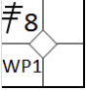 |  | /* Le premier batteur frappe un triple dans le champ centre */  action { batter -> 3B8 }  /* le coureur profite d'un lancer fou pour marque le point */  action { runner3 -> WP } |  | 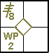

Example 130: With a runner on second base, the batter hits a sacrifice bunt that enables the runner to reach third base.
However, the pitcher, who catches the bunt, muffs his throw to first, enabling the runner to score and the batter to reach second base.
The run is not batted in as it was scored because of an error.
WBSC |  | Traduction dans l’outil de scorage |  | Outil
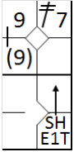 |  | /* le premier batteur frappe un double dans le champ gauche */  action { batter -> 2B7 }  /* Le batteur suivant fait un sacrifice hit, mais arrive sur base sur une erreur, le coureur avance et profite de l'erreur pour marquer */  action { batter -> SHE1T+ , runner2 -> + (2) } |  | 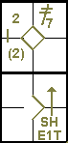

Example 131: With runners on first and third, the batter hits to the shortstop who passes the ball to the second baseman, who in turn puts out the runner from first, then throws to the first baseman, making a double play.
The runner on third scores.
The lead runner’s advance is entirely legal although the run cannot be counted as having been batted in, as it was scored on the back of a batted ball that led to a double play.
In this case it is important to remember to note the batting order number of the batter with a stroke above, to show that it is not a run batted in, despite the fact that the advance was legal.
WBSC |  | Traduction dans l’outil de scorage |  | Outil
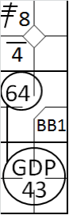 |  | /* Le premier batteur frappe un triple dans le champ centre */  action { batter -> 3B8 }  /* Le batteur suivant gagne la première base sur un 'base on ball' */  action { batter -> BB }  /* le batteur suivant frappe une balle au sol vers l'arrêt court ce qui entraine un double jeu, le coureur en 3 marque le point */  action { batter -> GDP43 , runner1 -> 64 , runner3 -> + } |  | 

Example 132: With two out and a runner on third base, the batter hits to the shortstop who bungles the catch, allowing he runner on third to score, and the batter to reach first base safely.
The run is not batted in as there were already two out, and if the shortstop had not made the error the inning would have been over.
WBSC |  | Traduction dans l’outil de scorage |  | Outil
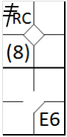 |  | /* Le premier batteur frappe un triple dans le champ centre */  action { batter -> 3BRC }  /* Le batteur suivant gagne la première base sur une erreur, me coureur profite de l'erreur pour marquer le point */  action { batter -> E6 , runner3 -> (2) } |  | 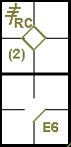
To conclude this section on runs batted in, we shall take this opportunity to draw your attention to a situation that arises often and which can place the scorer in some difficulties
Let us look at the following example.
Example 133: With a runner on second base, the batter hits a single to the center fielder, who lets the ball pass between his legs.
The runner on second base succeeds in scoring, while the batter reaches second base.
WBSC |  | Traduction dans l’outil de scorage |  | Outil
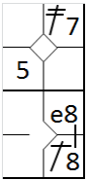 |  | /* Le premier coureur frappe un double dans le champ gauche */  action { batter -> 2B7 }  /* Le batteur suivant frappe un hit dans le champ centre et profite de l'erreur pour gagner la deuxième base, le coureur marque */  action { batter -> 1B8 e8 , runner2 -> ++ } |  | 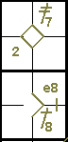
At this point, we ask ourselves whether the run was batted in or not, and whether the runner on second would have scored in any case, without the error by the center fielder.
To resolve this problem correctly, the scorer must follow developments on the field very closely, and must take particular note of the position of the runner at the point at which the fielder missed the ball, and whether he was close to the diamond or far away, which would make a throw to home plate very difficult.
He should make careful note of whether, once he reached third base, the runner slowed down and then picked up speed again once he had seen the fielder’s error, or whether he passed third base running and continued to home base without paying any attention to what was happening in the outfield.
If the scorer determines that the runner was heading for home base in any case, and that the fielder had made the error in a position that would have made it difficult for him to make a putout at home base, the batter should be credited with a run batted in.
If not, example 134, the run would not count as having been batted in.
WBSC |  | Traduction dans l’outil de scorage |  | Outil
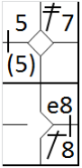 |  | /* Le premier coureur frappe un double dans le champ gauche */  action { batter -> 2B7 }  /* Le batteur suivant frappe un hit dans le champ centre et profite de l'erreur pour gagner la deuxième base, le coureur marque sur l'erreur */  action { batter -> 1B8 e8 , runner2 -> + (2) } |  | 